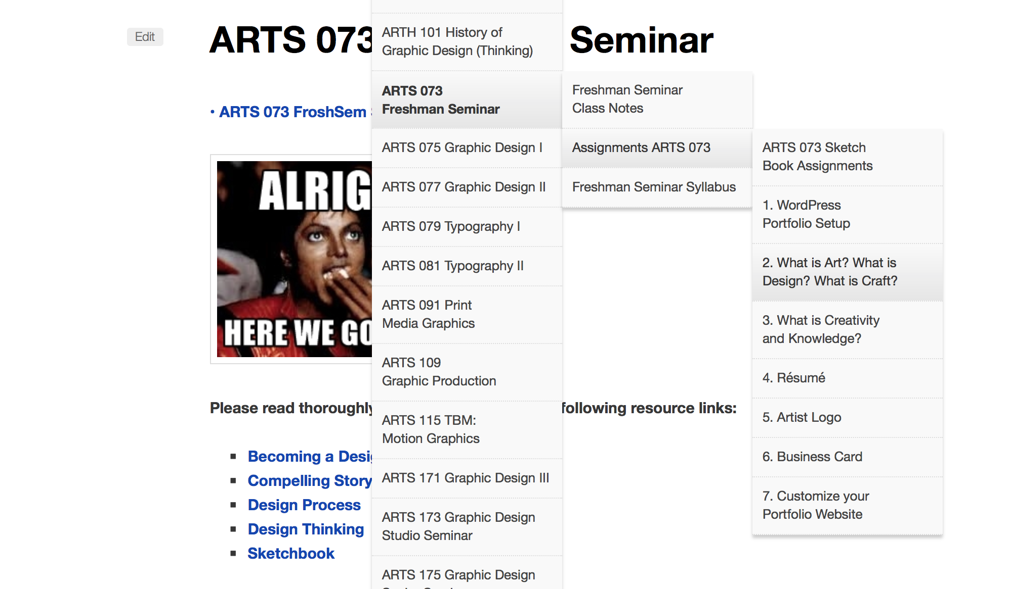

Your answers to the separate questions, “What is Art?” What is Design? What is Craft? What is the relationship between Creativity and Knowledge?” should each be written in short essay form. Each should be at least ½ page in length. Do not use phrases such as “in my opinion”, or “I think”, etc. Also do not say phrases such as “Art can be many things” or “Art means different things to different people”. The reason for this is first of all it is understood that the essays are your opinion therefore, you do not need to state it. Secondly, because you are writing the essay, it is also understood that the point is to give your interpretations of these subjects. It is not necessary to tell the reader that it could mean many other things in addition.

Paste each of your written essays separately on its own WordPress Page. Each of those Pages should be saved as “children” under the main “Parent” tab called “Writings” or something similar. To do this:
- you must create the Parent page first (in this example that would be the “writings” Page.
- Create the separate pages for each essay pasting in appropriate content and Publishing.
- From the Editing window for the page (the same place where you initially made the page) Under the column of choices on the left hand side find “Page Attributes” and press its downward pointing arrow/carrot.
- Locate the page that you wish to be the Parent of the page you are currently working on.
- Click the circle corresponding to the Parent page.
- Click Update and wait for the page to be saved. (you will see a green bar and a “view Page” button when this has completed.)

Be sure to read thoroughly the information and links from these pages on our website. They will answer the vast majority of questions concerning what you need to do as well as how to accomplish it.

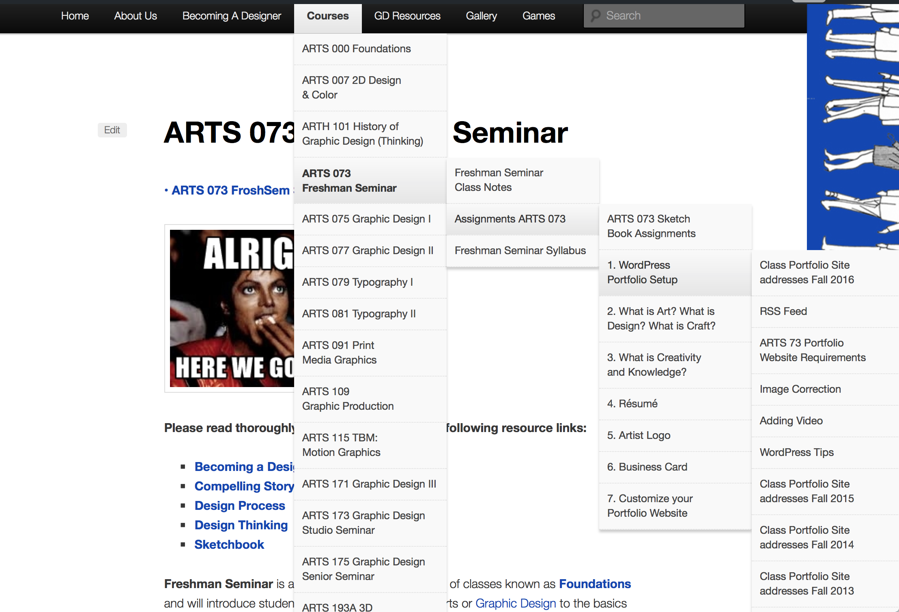

Remember Parent tabs should be very general headings, not specific things. Think of each level like you would an outline. Groups within groups. An example would be the following:

Parent: Gallery
Children Artwork Designwork

Grandchildren drawings posters
paintings logos
sculpture website
photography wearables

Great Grand-Children charcoal promotional posters
pencil advertising posters
marker

Create a main Home page
Settings
General
Site Title
Tagline
Click Customize to access the Static page option
https://en.support.wordpress.com/pages/front-page/

